To use the tar file to install the image use

open a command window here (powershell for windows). You must have docker desktop and WSL2 installed.

Docker load –input pythonapp-1.0.tar (note that is - - input – two dashes together before input)

If you want to build the image yourself (takes about 4 to 5 minutes)

Put the dockerfile and soilDB folder in the same folder and

You can build the image with

docker build --tag pythonapp:1.0 .    (don't forget the space and period at the end)

the dockerfile has a command to copy the python file from the folder soilDB, I’m not sure how it works for macs and linux

once you have the image you can create a container and run it as:

# creates and run a container called pa from the pythonapp image with the user ubuntu

docker run -it -u ubuntu --name pa  pythonapp:1.0

this creates and runs the container in 1 command. If you stop and want to start it later use:

docker start -i pa

here pa is the name of the container and -i says make it interactive so it opens a command window. The present folder will be /home/ubuntu

navigate to the folder soilDB that is in ubuntu (type cd soilDB). Then run:

python soilDB.py

you should get this:

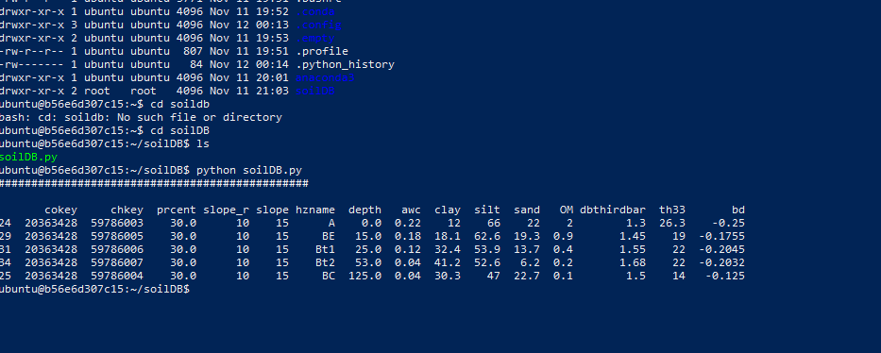

You can also manage images and containers as well as run them in docker desktop but I am finding the commands more flexible.

Just do Docker – (dash dash)help for info

The image is huge because of all the python libraries, my next goal is to make is smaller by using a requirements file to only get the libraries I need.